Kolbus 470 & 490 Installation Instructions
5mm & 6mm Fixed Hinge Varieties
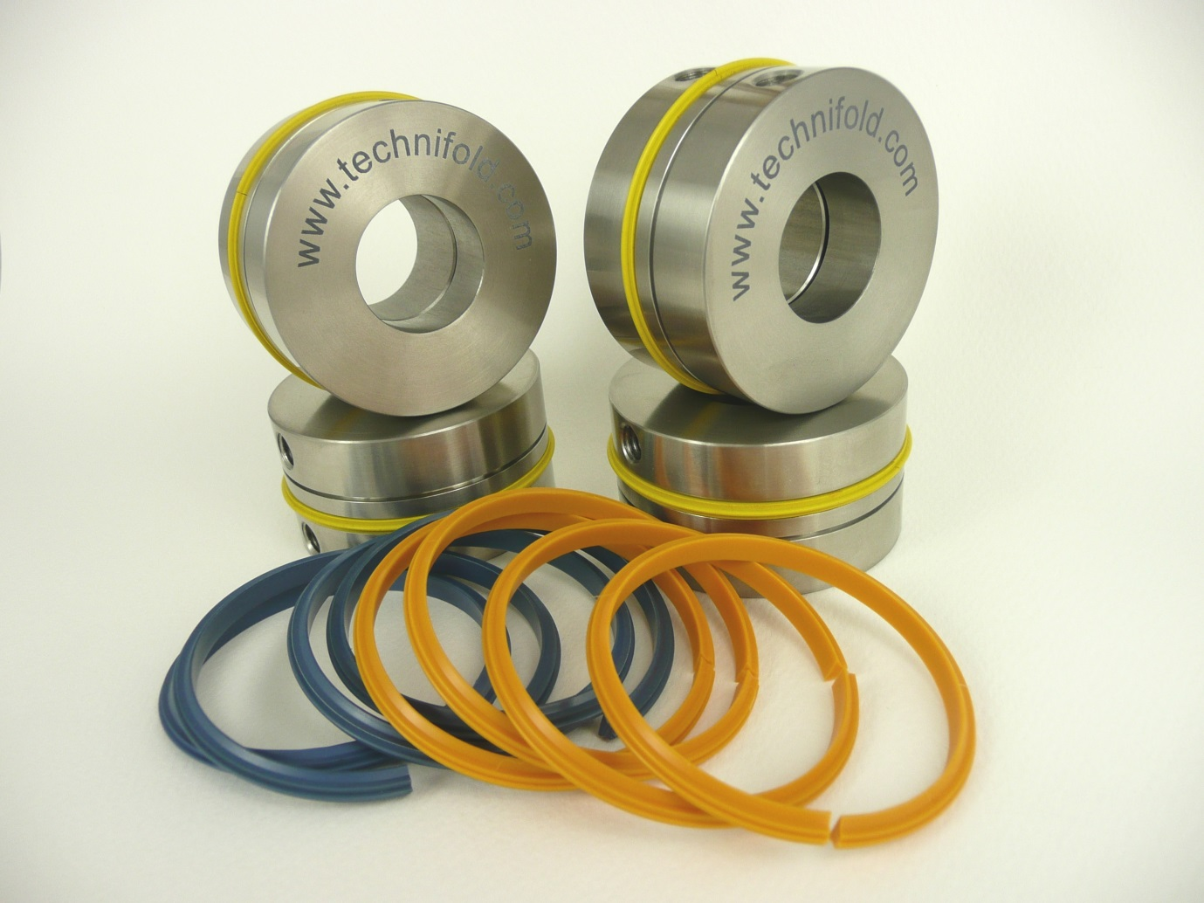

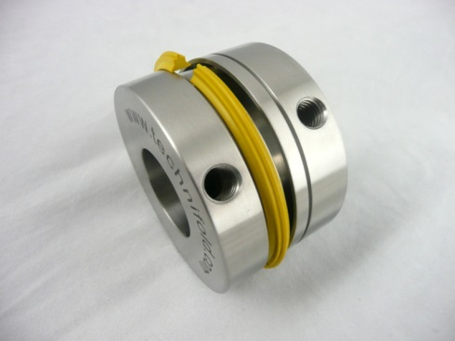
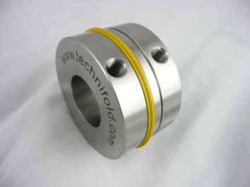

Once the crease units are placed on the shafts, the split crease ribs can be placed inside the components.



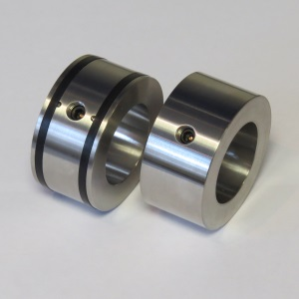
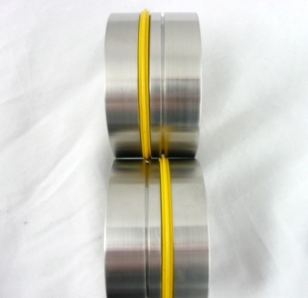

The top shaft support collar uses two gripper bands.
The bottom support collar is plain metal.
The creasing set consists of 4 identical components. Simply turning the crease unit 180 degrees will automatically align the tool (see above).

Installing the bottom shaft parts
Align a bottom crease unit with the edge of the book clamp and tighten fixing screws. Align the remaining bottom crease unit into the desired position and tighten the fixing screw.
Installing the top shaft parts
To achieve the correct grip between the support collars, align the top black grippers and the plain metal bottom collars to each end of the shaft. Slowly lower the top shaft until equal gentle grip pressure is obtained on both sides of the creasing shafts. As the top shaft is being lowered align the top male crease rib protrusion into the bottom female channel.
Do not tighten the top shaft fixing screws.
Jog a sheet of cover stock between the crease units. As the paper is fed between the creasing shafts the loose top shaft creasing units will automatically align themselves into the optimum creasing position. As the shafts rotate the fixing on the crease units become accessible. Tighten the screws while the paper is still positioned between the creasing units.

